FACULTY EVALUATION
Programme Name: SBVP ALUMNI MASTERCLASS Online s Module 2 Zambia (4th May 2026 - 8th May 2026)
Session: Reflections and Way Forward
Faculty Name: Dr. Nancy Nyambura Njiraini
No. of Respondents: 5
No. of Participants: 10
Evaluation Parameter | (%) Individual Score | (%) Programme Average
Punctuality (Commencement and Completion of Sessions) | 100 | 95
How well do you understand the core concepts presented? | 92 | 88
Rate your confidence in applying the new skills learnt | 76 | 85
Degree of Faculty preparedness for the sessions | 96 | 93
Content and methodology of the program | 96 | 95
Quality of class and group discussions | 92 | 91
The information presented in the course is relevant to my work (ministry) | 92 | 95
Average scores | 92 | 92

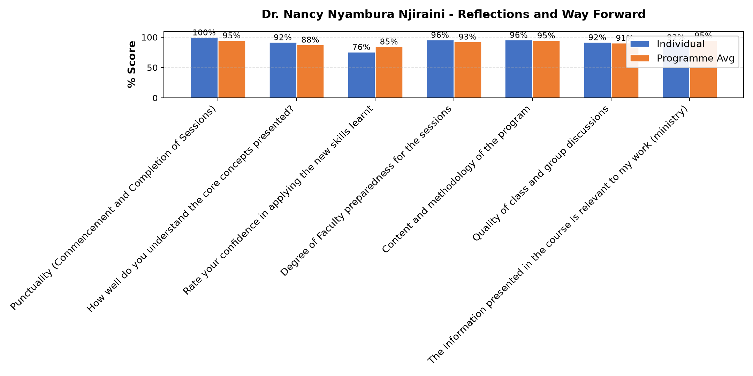

Comments & Feedback
- • Network problem for most participants and absentism
- • Lack of finance
- • The congregation doesn't involve us
- • Effort
SUBMITTED THROUGH:
SBS Evaluation Automation System

